**Capstone: The Battles of Neighborhoods**

**Introduction – Business Problem**

**Problem Background**

Toronto is a well-developed capital city of Canada, with lots of business opportunities and business friendly environment, it has no issue in attracting many different players into the market

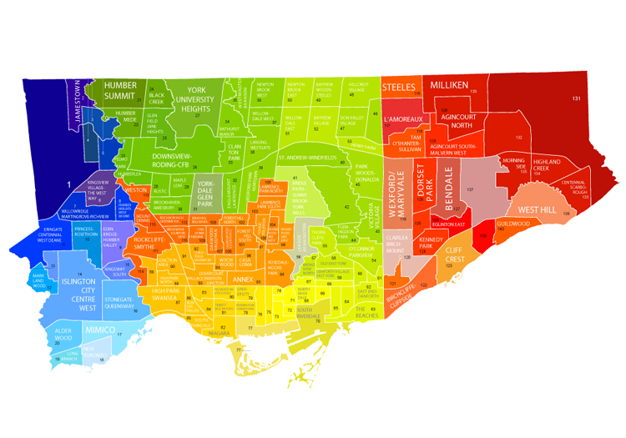

However, that also means the market is highly competitive and as a well-developed city, the cost of doing business is also one of the highest in the country. And thus, any new business venture or expansion in the country needs to be reviewed carefully and strategically targeted so that the return on investment will be sustainably reasonable and more importantly the investment can be considerably less risker.

**Problem Description**

There are approximately 88,000 pharmacies in the United States. Over half (about 48,000) are located within drug stores, grocery stores, hospitals, department stores, medical clinics, surgery clinics, universities, nursing homes, prisons, and other facilities. What about Community Pharmacies? Community Pharmacies offer basic preliminary health assessments in addition to dispensing prescriptions. The community pharmacist is considered to be the most accessible healthcare professional to the general public, as they are available to anyone on a walk-in basis. Approximately 9 out of 10 Americans live within 5 miles of a community pharmacy



Community pharmacists are considered to be the most accessible health professional to the public, as they are available to provide personalized advice about health and medicine on a walk-in basis, without the need for an appointment. 89% of the population in the United Kingdom can access a community pharmacy within a 20-minute walk. The community pharmacies are found to be scattered in city of Toronto. This is clearly a problem that people need to walk/drive more to access dedicated pharmacies. If they are out of time, they are compelled to make an appointment for hospitals.

**Target Audience**



To solve this problem, Data Scientist team led by myself has been engaged by Orange Drugs Inc. The objective is to locate and recommend to the management which neighborhood will be the best choice to start off their first retail Pharmacy. The management also expects to understand the rationale of the recommendations in the report.

**Success Criteria**

The success criteria of this project will be a good recommendation of the neighborhood choice in Toronto to the management of Orange Drugs Inc based on following factors:

1. Lack of Pharmacy stores available (less competition).
2. Number of Hospital around.
3. Higher number of Hospital Admissions (higher demand).
4. Population Size.